What is an Array in Java?
An array in Java is a data structure that stores multiple values of the same data type in a single variable. The values are stored in contiguous memory locations and each element is accessed using an index.
- Index starts from 0
- Array size is fixed once it is created.
- All elements must be of the same data type.
Definition
An array is a collection of similar (same data type) elements stored in contiguous memory locations and accessed using an index.
If we want to perform operations such as searching, sorting, inserting, deleting, or updating data efficiently, the data should be stored in an organized manner. An array stores elements of the same data type in contiguous memory locations, making it easy to access and process the data using indexes.
Types of Arrays in Java
1. One-Dimensional (1D) Array
A one-dimensional array stores elements in a single row. Each element is accessed using a single index.
Array Initialization:
In this method, the array is created and initialized with values in a single statement.
Syntax
dataType[] arrayName = {value1, value2, value3, ...};
Example:
int arr[] = {10, 20, 30, 40, 50};
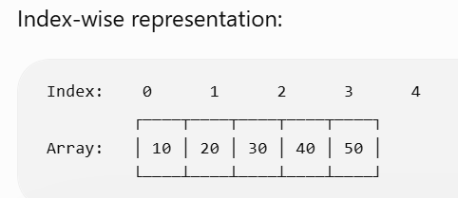

Example
public class ArrayInitializationDemo
{
public static void main(String[] args)
{
Int marks[] = {85, 90, 78, 88, 92};
System.out.println("Student Marks:");
for(int i = 0; i < marks.length; i++)
{
System.out.println(marks[i]);
}
}
}

Array Creation Expression:
In this method, memory is allocated for the array using the new keyword. The array elements are initialized with their default values.
Syntax
dataType[] arrayName = new dataType[size];
Example
import java.util.Scanner;
public class ArrayCreationDemo
{
public static void main(String[] args)
{
Int size marks[];
Scanner sc = new Scanner(System.in);
System.out.println(“How many elelment do you want to input: ”);
size = sc.nextInt();
// Array Creation Expression
marks = new int[size];
System.out.println("Enter 5 marks:");
// Input array elements
for(int i = 0; i < marks.length; i++)
{
marks[i] = sc.nextInt();
}
System.out.println("\nEntered Marks:");
// Display array elements
for(int i = 0; i < marks.length; i++)
{
System.out.println(marks[i]);
}
}
}
Anonymous Array:
An anonymous array is an array without a reference variable (name). It is generally used to pass values directly to a method when the array is required only once.
Syntax
new dataType[]{value1, value2, value3, ...}
public class AnonymousArrayDemo
{
public static void main(String[] args)
{
display(new int[]{10, 20, 30, 40, 50});
}

Public static void display(int[] arr)
{
for(int i = 0; i < arr.length; i++)
{
System.out.println(arr[i]);
}
}
}

Call by Value Example (Primitive Variable)
public class CallByValueDemo
{
public static void main(String[] args)
{
int a = 10;
System.out.println("Before Method Call = " + a);

change(a);
System.out.println("After Method Call = " + a);
}
Public static void change(int x)
{
x = x+10;
System.out.println("Inside Method = " + x);
}
}

Call by Reference Example (Using Array)

public class CallByReferenceDemo
{
public static void main(String[] args)
{
int[] numbers = {10, 20, 30};
System.out.println("Before Method Call = " + numbers[0]);

change(numbers);
System.out.println("After Method Call = " + numbers[0]);
}
static void change(int[] arr)
{
arr[0] = 100;
}

}

2. Two-Dimensional (2D) Array
A two-dimensional array stores data in the form of rows and columns (a table or matrix). Each element is accessed using two indexes: row and column.
Declaration Syntax:
datatype [][]arrayName;
dataType arrayName[][];
datatype []arrayName[];
2D Array using Initialization
class InitializationExample {
public static void main(String[] args) {
int[][] arr = {
{10, 20, 30},
{40, 50, 60},
{70, 80, 90}
};

for(int i = 0; i < arr.length; i++) {
for(int j = 0; j < arr[i].length; j++) {
System.out.print(arr[i][j] + "\t");
}
System.out.println();
}
}
}
Row and Column Index Representation
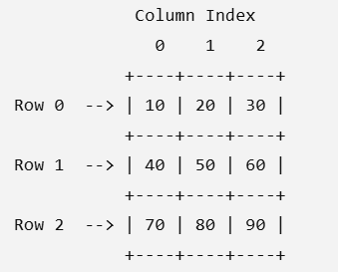

2D Array using Array Creation Expression
import java.util.*;
class TwoDArrayCreationExample {
public static void main(String[] args) {
int r,c, arr[][];
Scanner sc = new Scanner(System.in);
System.out.println("Enter the row and column: ");
r = sc.nextInt();
c = sc.nextInt();

arr = new int[r][c];
System.out.println("Enter the matrix element: ");

for(int i = 0; i < arr.length; i++) {
for(int j = 0; j < arr[i].length; j++) {
arr[i][j] = sc.nextInt();
}
}

System.out.println("Your matrix is as below: ");
for(int i = 0; i < arr.length; i++) {
for(int j = 0; j < arr[i].length; j++) {
System.out.print(arr[i][j] + " ");
}
System.out.println();
}
}
}

2D Array using Anonymous Array
class AnonymousArrayExample {
public static void main(String[] args) {

printArray(new int[][]{
{10, 20, 30},
{40, 50, 60}
});
}
static void printArray(int[][] arr) {
for(int i = 0; i < arr.length; i++) {
for(int j = 0; j < arr[i].length; j++) {
System.out.print(arr[i][j] + " ");
}
System.out.println();
}
}
}

